# Bansilal Ramnath Agarwal Charitable Trust’s

Vishwakarma Institute of Technology, Pune -37

*(An autonomous Institute of Savitribai Phule Pune University)*



**Department of Artificial intelligence and Data Science**

| **Division** | A |
| --- | --- |
| **Batch** | 3 |
| **Roll no** | 68 |
| **PRN no** | 12320041 |
| **Name** | Heramb Sachin Bhoodhar |
| **Subject** | Web Technology |

**Assignment 1**

**Problem Statement :**

Design and implement a web page to demonstrate the use of different HTML tags

1. Page Title

2. Heading

3. Div

4. Paragraph (Text Formatting and color formatting)

5. Images

6. Blocks

7. Table

8. List

9. Forms

10. Graphics

**Theory :**

* **<title>**: Defines the title of the HTML document displayed in the browser's title bar or tab.
* **<h1>-<h6>**: Defines headings of varying levels, with <h1> being the most important and <h6> being the least important.
* **<div>**: Defines a division or section in an HTML document, often used for grouping and styling content.
* **<p>**: Defines a paragraph of text in an HTML document, typically used for longer blocks of text.
* **<img>**: Inserts an image into an HTML document, allowing for visual content.
* **<div>** (Blocks): Utilizes the <div> element for creating block-level containers for organizing and styling content.
* **<ul>,<li>**: Creates unordered (<ul>) or ordered (<ol>) lists, with individual list items represented by <li> tags.
* **<form>**: Defines a form in an HTML document, used for collecting user input with various input elements such as text fields, buttons, checkboxes, etc.

**CODE :**

**HTML -**

<!DOCTYPE html>

<html lang="en">

<meta charset="UTF-8">

<meta name="viewport" content="width=device-width, initial-scale=1.0">

<link rel="stylesheet" href="index.css">

<title>Landing Page</title>

</head>

<body>

<header>

<nav>

<div class="logo">

Coder X

</div>

<div class="menu">

<a href="#">Home</a>

<a href="#">About Us</a>

<a href="#">Our Products</a>

<a href="#">Contact Us</a>

</div>

<div class="register">

<a href="#">Register Now</a>

</div>

</nav>

</header>

<section class="h-txt">

<span>Compete In</span>

<h1>International Hackathons</h1>

<br>

<a href="#">Learn Now</a>

</section>

<section class="contact">

<h1 style="font-size: xx-large">Contact me</h1>

<div class="container">

<form action="#">

<label for="fname">Your Name</label>

<input

type="text"

id="fname"

name="firstname"

placeholder="Your name.."

/>

<label for="lname">Your Email</label>

<input

type="text"

id="lname"

name="lastname"

placeholder="Your last name.."

/>

<label for="subject">Subject</label>

<textarea

id="subject"

name="subject"

placeholder="Write something.."

style="height: 200px"

></textarea>

<input type="submit" value="Submit" />

</form>

</div>

</section>

<section style="height: 10vh; ">

<hr>

<footer style="display: flex; justify-content: space-evenly; align-items: center; margin-top: 1rem;">

<div class="logo">

Coder X

</div>

<p>Made with ❤️ by Heramb Bhoodhar 2024</p>

<div style="display: flex; justify-content: space-around;">

<a href="https://twitter.com/Heramb120" target="_blank">

<svg xmlns="http://www.w3.org/2000/svg" style="margin: 0px 10px;" height="20px" width="20px" viewBox="0 0 512 512"><!--!Font Awesome Free 6.5.1 by @fontawesome - https://fontawesome.com License - https://fontawesome.com/license/free Copyright 2024 Fonticons, Inc.--><path d="M389.2 48h70.6L305.6 224.2 487 464H345L233.7 318.6 106.5 464H35.8L200.7 275.5 26.8 48H172.4L272.9 180.9 389.2 48zM364.4 421.8h39.1L151.1 88h-42L364.4 421.8z"/></svg>

</a>

<a href="https://www.linkedin.com/in/heramb-bhoodhar-a09a22225/?originalSubdomain=in" target="_blank">

<svg xmlns="http://www.w3.org/2000/svg" style="margin: 0px 10px;" height="20px" width="20px" viewBox="0 0 448 512"><!--!Font Awesome Free 6.5.1 by @fontawesome - https://fontawesome.com License - https://fontawesome.com/license/free Copyright 2024 Fonticons, Inc.--><path d="M416 32H31.9C14.3 32 0 46.5 0 64.3v383.4C0 465.5 14.3 480 31.9 480H416c17.6 0 32-14.5 32-32.3V64.3c0-17.8-14.4-32.3-32-32.3zM135.4 416H69V202.2h66.5V416zm-33.2-243c-21.3 0-38.5-17.3-38.5-38.5S80.9 96 102.2 96c21.2 0 38.5 17.3 38.5 38.5 0 21.3-17.2 38.5-38.5 38.5zm282.1 243h-66.4V312c0-24.8-.5-56.7-34.5-56.7-34.6 0-39.9 27-39.9 54.9V416h-66.4V202.2h63.7v29.2h.9c8.9-16.8 30.6-34.5 62.9-34.5 67.2 0 79.7 44.3 79.7 101.9V416z"/></svg>

</a>

<a href="https://github.com/Heramb4270?tab=repositories" target="_blank">

<svg xmlns="http://www.w3.org/2000/svg" style="margin: 0px 10px;" height="20px" width="20px" viewBox="0 0 496 512"><!--!Font Awesome Free 6.5.1 by @fontawesome - https://fontawesome.com License - https://fontawesome.com/license/free Copyright 2024 Fonticons, Inc.--><path d="M165.9 397.4c0 2-2.3 3.6-5.2 3.6-3.3 .3-5.6-1.3-5.6-3.6 0-2 2.3-3.6 5.2-3.6 3-.3 5.6 1.3 5.6 3.6zm-31.1-4.5c-.7 2 1.3 4.3 4.3 4.9 2.6 1 5.6 0 6.2-2s-1.3-4.3-4.3-5.2c-2.6-.7-5.5 .3-6.2 2.3zm44.2-1.7c-2.9 .7-4.9 2.6-4.6 4.9 .3 2 2.9 3.3 5.9 2.6 2.9-.7 4.9-2.6 4.6-4.6-.3-1.9-3-3.2-5.9-2.9zM244.8 8C106.1 8 0 113.3 0 252c0 110.9 69.8 205.8 169.5 239.2 12.8 2.3 17.3-5.6 17.3-12.1 0-6.2-.3-40.4-.3-61.4 0 0-70 15-84.7-29.8 0 0-11.4-29.1-27.8-36.6 0 0-22.9-15.7 1.6-15.4 0 0 24.9 2 38.6 25.8 21.9 38.6 58.6 27.5 72.9 20.9 2.3-16 8.8-27.1 16-33.7-55.9-6.2-112.3-14.3-112.3-110.5 0-27.5 7.6-41.3 23.6-58.9-2.6-6.5-11.1-33.3 2.6-67.9 20.9-6.5 69 27 69 27 20-5.6 41.5-8.5 62.8-8.5s42.8 2.9 62.8 8.5c0 0 48.1-33.6 69-27 13.7 34.7 5.2 61.4 2.6 67.9 16 17.7 25.8 31.5 25.8 58.9 0 96.5-58.9 104.2-114.8 110.5 9.2 7.9 17 22.9 17 46.4 0 33.7-.3 75.4-.3 83.6 0 6.5 4.6 14.4 17.3 12.1C428.2 457.8 496 362.9 496 252 496 113.3 383.5 8 244.8 8zM97.2 352.9c-1.3 1-1 3.3 .7 5.2 1.6 1.6 3.9 2.3 5.2 1 1.3-1 1-3.3-.7-5.2-1.6-1.6-3.9-2.3-5.2-1zm-10.8-8.1c-.7 1.3 .3 2.9 2.3 3.9 1.6 1 3.6 .7 4.3-.7 .7-1.3-.3-2.9-2.3-3.9-2-.6-3.6-.3-4.3 .7zm32.4 35.6c-1.6 1.3-1 4.3 1.3 6.2 2.3 2.3 5.2 2.6 6.5 1 1.3-1.3 .7-4.3-1.3-6.2-2.2-2.3-5.2-2.6-6.5-1zm-11.4-14.7c-1.6 1-1.6 3.6 0 5.9 1.6 2.3 4.3 3.3 5.6 2.3 1.6-1.3 1.6-3.9 0-6.2-1.4-2.3-4-3.3-5.6-2z"/></svg>

</a>

</div>

</footer>

</section>

</body>

</html>

**CSS :**

* {

padding: 0;

margin: 0;

font-family: sans-serif;

}

header {

height: 100vh;

width: 100%;

background: linear-gradient(rgba(0, 0, 0, 0.6), rgba(0, 0, 0, 0.2)),

url("./img/img1.jpg");

background-size: cover;

}

nav {

width: 100%;

height: 100px;

color: white;

display: flex;

justify-content: space-around;

align-items: center;

}

.logo {

font-size: 2em;

letter-spacing: 2px;

}

.menu a {

text-decoration: none;

color: white;

padding: 10px 20px;

font-size: 1.2em;

}

.menu a:hover {

background: rgb(255, 255, 194);

color: black;

border-radius: 6px;

}

.register a {

text-decoration: none;

color: black;

padding: 10px 20px;

background: rgb(255, 255, 194);

border-radius: 8px;

}

.h-txt {

max-width: 650px;

position: absolute;

top: 50%;

left: 50%;

transform: translate(-50%, -50%);

text-align: center;

color: white;

}

.h-txt span {

letter-spacing: 5px;

}

.h-txt h1 {

font-size: 3.5em;

}

.h-txt a {

text-decoration: none;

background: rgb(255, 255, 194);

color: white;

padding: 10px 20px;

letter-spacing: 5px;

color: black;

}

.contact h1 {

display: flex;

justify-content: center;

align-items: center;

margin-top: 3rem;

margin-bottom: 2rem;

}

.contact {

display: flex;

flex-direction: column;

width: 70vw;

margin: auto;

}

input[type="text"],

select,

textarea {

width: 100%;

padding: 12px;

border: 1px solid #ccc;

border-radius: 4px;

box-sizing: border-box;

margin-top: 6px;

margin-bottom: 16px;

resize: vertical;

}

input[type="submit"] {

background-color: #04aa6d;

color: white;

padding: 12px 20px;

border: none;

border-radius: 4px;

cursor: pointer;

}

input[type="submit"]:hover {

background-color: #45a049;

}

.container {

border-radius: 5px;

background-color: #f2f2f2;

padding: 20px;

}

**OUTPUT :**





**HOVER EFFECT IN NAVBAR**

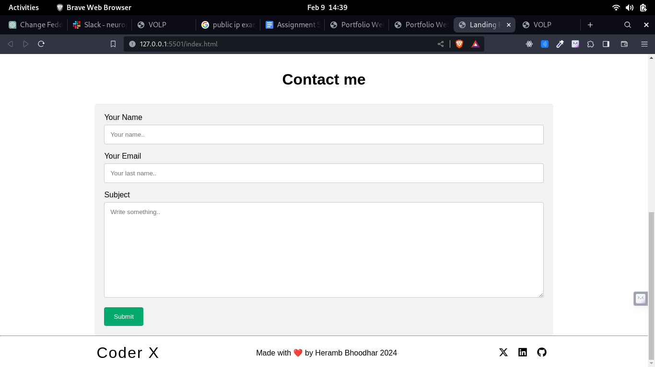

**Contact Form and Footer**